**Full Stack Development with MERN**

**1.Introduction**

**Project Title: Online Complaint Registration And Management System**

* **Team Members:**

**Dharshan S (311521104011)-Team Lead**

**Anto Ranjith C(311521104006)-Member**

**Jagadeep T(311521104021)-Member**

**Yathindrapravanan TV(311521104063)-Member**

**2. Project Overview**

* **Purpose:**

The purpose of the **Online Complaint Registration and Management System** is to provide a structured and efficient platform for users to register complaints and track their resolution process. This system aims to streamline the management of complaints, reduce response times, and ensure transparency in the complaint resolution process. By offering real-time updates, secure data handling, and a direct communication channel with support agents, it empowers users and organizations to address and resolve issues promptly.

For organizations, the system serves as a powerful tool to manage customer relations effectively, improve service quality, and uphold compliance standards. For users, it simplifies the complaint submission process, enhances their experience by providing timely updates, and promotes trust by safeguarding their information. In essence, the system bridges the gap between users and organizations, fostering a proactive approach to resolving issues and improving overall satisfaction.

* **Features:**

The **Online Complaint Registration and Management System** includes a range of features designed to ensure a smooth and efficient complaint handling process for both users and administrators. Key features include:

1. **User Registration and Login**  
   Users can create and manage their accounts, enabling secure access to the system. This allows them to submit complaints, track progress, and view complaint history. The login feature also includes multi-factor authentication for enhanced security.
2. **Complaint Submission**  
   Users can easily submit complaints by filling out a detailed form that captures necessary information, such as the nature of the complaint, description, relevant documents or images, contact details, and location. This organized input ensures that agents have all the details needed to address each complaint efficiently.
3. **Complaint Tracking and Notifications**  
   The system provides real-time tracking, allowing users to monitor the status of their complaints at every stage. Additionally, users receive notifications via email or SMS whenever there is an update, such as assignment to an agent, progress changes, or resolution status, keeping them informed throughout the process.
4. **Interaction with Assigned Agents**  
   Users can communicate directly with the assigned support agent using a built-in messaging feature. This interaction enables users to provide additional information if needed and receive clarifications, making the complaint resolution process more transparent and responsive.
5. **Assignment and Routing of Complaints**  
   Complaints are intelligently routed to the appropriate department or personnel based on predefined criteria such as type, priority, and workload. This ensures that each complaint is handled by the most qualified agent, reducing resolution times and improving overall efficiency.
6. **Administrative Control and Monitoring**  
   Administrators have access to a comprehensive dashboard to oversee all complaints registered on the platform. They can assign complaints, monitor the progress, and view overall system performance. The dashboard also provides insights into agent workloads and response times, helping administrators maintain an efficient complaint resolution process.
7. **Feedback Collection and Analysis**  
   After a complaint is resolved, users can provide feedback on the handling process. This feedback is valuable for continuous improvement, allowing organizations to assess agent performance and enhance service quality based on user input.
8. **Security and Confidentiality**  
   The system employs robust security measures, including user authentication, data encryption, and strict access controls. It is designed to comply with data protection regulations, ensuring that all user information and complaint details are securely stored and managed, fostering user trust and confidentiality.
9. **Data Analytics and Reporting**  
   The system includes analytical tools for generating reports on complaint patterns, resolution times, and customer satisfaction metrics. This data supports strategic decision-making, helping organizations identify recurring issues and trends that may require proactive action.
10. **Multi-Platform Accessibility**  
    Built with responsive design, the system is accessible from various devices, including desktops, tablets, and smartphones, ensuring a seamless user experience across different platforms.

**3. Architecture**

* **Frontend:**

The frontend of the **Online Complaint Registration and Management System** is built using **React**, a powerful JavaScript library ideal for creating dynamic and responsive user interfaces. React’s component-based architecture makes the application modular, maintainable, and scalable, ensuring a smooth user experience.

1. **Component-Based Structure**  
   The frontend is divided into reusable, independent components that manage their own state. Components such as Header, Footer, LoginForm, ComplaintForm, Dashboard, and ChatBox are designed to handle specific functionalities. This modularity enhances code organization, enabling developers to update or reuse components across different parts of the application efficiently.
2. **Single-Page Application (SPA)**  
   Using React Router, the application functions as a Single-Page Application (SPA), where users can navigate between pages (like the dashboard, complaint submission form, and tracking page) without reloading the entire page. This SPA approach minimizes load times and provides a seamless user experience as only necessary content is updated on each interaction.
3. **State Management**  
   React’s **useState** and **useContext** hooks are used to manage component-level and global states, respectively. For larger-scale state management, the app can incorporate **Redux** or React’s Context API, allowing centralized control of state across components. This is crucial for handling data consistency across various features, such as user authentication, complaint status updates, and notification handling.
4. **API Integration with Axios**  
   The frontend communicates with the backend via RESTful APIs using **Axios**, a popular HTTP client for handling API requests and responses. Axios is configured globally to manage requests related to complaint submission, tracking, user authentication, and notifications. It also allows error handling, token-based authentication, and response management to provide a consistent data exchange between the frontend and backend.
5. **Responsive Design with Material-UI and Bootstrap**  
   To ensure a responsive and visually appealing interface, the app utilizes **Material-UI** and **Bootstrap**. Material-UI provides pre-built components that adhere to Google’s Material Design principles, offering a clean and accessible design. Bootstrap adds further styling capabilities, making the application accessible across various devices, including desktops, tablets, and mobile phones.
6. **Real-Time Updates with WebSockets**  
   For features like real-time agent-user interactions and live complaint status updates, the frontend leverages **Socket.IO** integrated with React. This setup allows for bidirectional communication with the backend, enabling instant updates to the complaint status, notifications, and chat messages without reloading the page, which enhances user engagement and satisfaction.
7. **Form Validation and Error Handling**  
   The application uses libraries like **Formik** and **Yup** for efficient form validation, ensuring that users enter correct and complete information when registering complaints or updating their profile. This validation minimizes errors and improves data quality before submission to the backend.
8. **Security Measures**  
   Security is implemented on the frontend by following best practices, such as token-based authentication and secure data handling. Sensitive data, like authentication tokens, are stored in HTTP-only cookies or secure storage solutions to prevent unauthorized access. Additionally, CSRF protection and error handling are implemented to prevent vulnerabilities in user interactions.
9. **Optimized Performance with Code Splitting and Lazy Loading**  
   To ensure optimal performance, code splitting and lazy loading are implemented. By dynamically loading components only when needed (such as loading the chat interface when a user initiates a conversation), the initial load time is minimized, and the application remains responsive.
10. **Testing and Debugging with React Developer Tools and Jest**  
    The frontend is thoroughly tested using **Jest** and **React Testing Library** to validate component functionality and UI behavior. **React Developer Tools** aids in debugging, allowing developers to inspect component hierarchies, track states, and identify issues within the application.

* **Backend:**

The backend of the **Online Complaint Registration and Management System** is designed with **Node.js** and **Express.js** to ensure efficient, scalable, and fast server-side operations. This architecture enables real-time processing, secure data management, and robust support for a variety of client-side interactions.

1. **Express.js Framework for Routing and Middleware**  
   Express.js serves as the core framework, handling all HTTP routing and middleware management. Each endpoint is structured as a RESTful route (e.g., /login, /submit-complaint, /track-complaint), making API requests predictable and easy to maintain. Middleware functions are utilized for error handling, logging, authentication, and request validation.
2. **Modular Structure**  
   The backend is organized into modular layers:
   * **Controllers:** Handle incoming requests, call services to process business logic, and return appropriate responses to the client.
   * **Services:** Contain the core business logic for operations like complaint submission, user registration, complaint tracking, and agent assignment. This separation of concerns allows for better maintainability and testing.
   * **Models:** Define the structure of MongoDB collections using **Mongoose** schemas, ensuring data integrity and consistency in storage.
3. **Database Management with MongoDB and Mongoose**  
   MongoDB serves as the NoSQL database for storing user profiles, complaints, statuses, and interactions. **Mongoose**, an Object Data Modeling (ODM) library, is used to define schemas, enforce data validation, and streamline MongoDB interactions. Collections like Users, Complaints, and Agents are structured to allow for easy retrieval and modification of data as needed.
4. **RESTful API Design**  
   The backend exposes RESTful APIs for each core operation (e.g., registering a user, submitting a complaint, tracking a complaint). This setup supports scalable integration with the frontend, allowing a seamless flow of information across the platform. Each API endpoint includes input validation and error handling to maintain data accuracy and provide informative error messages to the frontend.
5. **Authentication and Authorization with JWT**  
   The backend uses **JSON Web Tokens (JWT)** for user authentication. Upon successful login, a JWT is generated and sent to the client, where it is stored securely (e.g., in HTTP-only cookies). Subsequent requests include this token to validate the user’s identity and ensure secure access to protected routes. Role-based access control (e.g., user, agent, admin) is also implemented to restrict certain actions to authorized users only.
6. **Real-Time Communication with Socket.IO**  
   For real-time updates, such as status changes or live chat between users and agents, the backend integrates **Socket.IO** to enable bidirectional communication between the server and clients. This is essential for providing instant notifications, updates, and a smooth chat experience, making complaint resolution quicker and more interactive.
7. **Error Handling and Logging**  
   A centralized error-handling middleware is used to capture errors, format responses, and send relevant information back to the client. Logging libraries such as **Winston** are employed to record request logs, errors, and other critical events. Logs are stored and monitored to assist in debugging and maintaining the system’s health.
8. **Data Validation with Joi**  
   The **Joi** library is used to validate incoming data for each API request, ensuring that data formats and fields meet required criteria before processing. This step minimizes incorrect data from entering the system, enhancing data quality and preventing potential errors during processing.
9. **Security Practices**  
   To secure data and protect against vulnerabilities:
   * **Input Sanitization:** Input data is sanitized to prevent attacks like SQL injection and cross-site scripting (XSS).
   * **CORS Configuration:** Cross-Origin Resource Sharing (CORS) is configured to allow only trusted domains to access the API.
   * **Rate Limiting:** Request rate-limiting prevents abuse of API endpoints by limiting the number of requests a client can make in a given timeframe.
10. **Scalability and Load Balancing**  
    The backend is designed to be horizontally scalable, allowing the system to handle increased loads by adding more server instances. Load balancers can distribute incoming requests across multiple instances, optimizing performance during high-traffic periods and ensuring reliable service.

* **Database:**

The **Online Complaint Registration and Management System** uses **MongoDB**, a NoSQL database, to store and manage data in a flexible, scalable manner. MongoDB's document-based structure allows the system to handle diverse and dynamic data types efficiently. The system uses **Mongoose**, an ODM (Object Data Modeling) library, to define schemas and interact with the MongoDB database.

**a. Database Schema**

The database schema consists of multiple collections, each designed to manage different aspects of the complaint management process. Below are the main collections and their schema definitions:

**a.1 Users Collection**

This collection stores data related to users who register and submit complaints.

const UserSchema = new mongoose.Schema({ username: { type: String, required: true, unique: true }, email: { type: String, required: true, unique: true }, password: { type: String, required: true }, role: { type: String, enum: ['user', 'agent', 'admin'], default: 'user' }, // Role-based access control complaints: [{ type: mongoose.Schema.Types.ObjectId, ref: 'Complaint' }], // Reference to complaints filed by the user createdAt: { type: Date, default: Date.now }, });

**Fields:**

* username: Unique identifier for the user.
* email: User’s email address for communication.
* password: Encrypted password for user login.
* role: Defines whether the user is an admin, agent, or regular user.
* complaints: References the complaints submitted by the user (using ObjectId).
* createdAt: Date of user registration.

**a.2 Complaints Collection**

This collection stores the details of each complaint submitted by the users.

**Schema Definition:**

const ComplaintSchema = new mongoose.Schema({ user: { type: mongoose.Schema.Types.ObjectId, ref: 'User', required: true }, // Reference to the user submitting the complaint title: { type: String, required: true }, // Short description of the complaint description: { type: String, required: true }, // Detailed description of the issue status: { type: String, enum: ['submitted', 'in-progress', 'resolved', 'closed'], default: 'submitted' }, // Complaint status priority: { type: String, enum: ['low', 'medium', 'high'], default: 'medium' }, // Complaint priority assignedAgent: { type: mongoose.Schema.Types.ObjectId, ref: 'Agent' }, // Reference to assigned agent createdAt: { type: Date, default: Date.now }, updatedAt: { type: Date }, resolutionDetails: { resolutionStatus: { type: String, enum: ['resolved', 'unresolved'], default: 'unresolved' }, resolutionDate: { type: Date }, notes: { type: String } }, });

* **Fields:**
  + user: Reference to the user who submitted the complaint.
  + title: A brief title or subject of the complaint.
  + description: A detailed description of the complaint issue.
  + status: The current status of the complaint (e.g., submitted, in-progress, resolved, closed).
  + priority: The priority level of the complaint (low, medium, high).
  + assignedAgent: Reference to the agent assigned to resolve the complaint.
  + createdAt: Date the complaint was submitted.
  + updatedAt: Date the complaint was last updated.
  + resolutionDetails: Includes the resolution status, date, and any notes or comments on the resolution.

**b.Database Interactions with MongoDB**

MongoDB provides an efficient way to store and retrieve data using **Mongoose**. The backend performs CRUD (Create, Read, Update, Delete) operations to manage users, complaints, agents, and other related data.

* **User Registration:**  
  When a new user registers, their data is stored in the Users collection. A unique identifier (e.g., user._id) is created for each user. On registration, the backend may hash the password for security.
* **Complaint Submission:**  
  When a user submits a complaint, a new document is created in the Complaints collection. The complaint is linked to the user via the user field, and a status of submitted is set. If there’s an assigned agent, the assignedAgent field is populated.
* **Complaint Status Update:**  
  As the complaint progresses, the status (submitted, in-progress, resolved, closed) is updated. This is done using MongoDB’s update or findOneAndUpdate methods, where the status and updatedAt fields are modified.
* **Agent Assignment:**  
  The admin or the system can assign complaints to agents by updating the assignedAgent field of the complaint document. The agent’s assignedComplaints field is also updated with the complaint's _id.
* **Complaint Resolution:**  
  Once the complaint is resolved, the resolutionDetails field is updated with the resolution status, resolution date, and any notes from the agent. The status is also changed to resolved.
* **User-Complaint Relationship:**  
  The Users collection has a reference (complaints) to the Complaints collection, allowing easy access to all complaints filed by a specific user.
* **Data Retrieval:**  
  Data is retrieved using Mongoose queries such as find(), findOne(), and populate() to gather related documents. For example, fetching a complaint along with its assigned agent can be done using .populate('assignedAgent') to join data between the Complaints and Agents collections.

**c.Indexes for Optimization**

To optimize query performance, especially when searching for specific users or complaints, MongoDB indexes are created on frequently queried fields like email, username, status, and assignedAgent:

UserSchema.index({ email: 1 });

ComplaintSchema.index({ status: 1 });

**ER DIAGRAM:-**

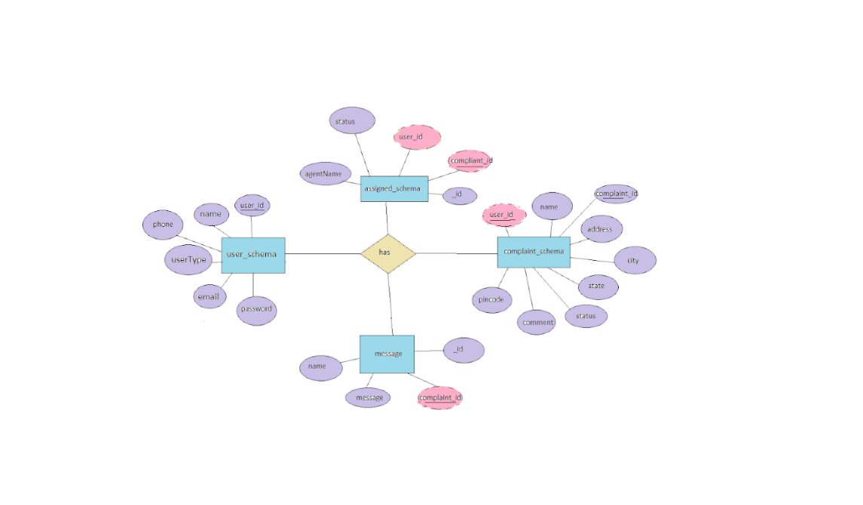

**4. Setup Instructions**

* **Prerequisites:**

Here are the key prerequisites for developing a full-stack application using Node.js, Express.js, MongoDB, React.js:

**Node.js and npm:**

Node.js is a powerful JavaScript runtime environment that allows you to run JavaScript code on the server-side. It provides a scalable and efficient platform for building network applications.

Install Node.js and npm on your development machine, as they are required to run JavaScript on the server-side.

Download: https://nodejs.org/en/download/

Installation instructions: https://nodejs.org/en/download/package-manager/

**Express.js:**

Express.js is a fast and minimalist web application framework for Node.js. It simplifies the process of creating robust APIs and web applications, offering features like routing, middleware support, and modular architecture.

Install Express.js, a web application framework for Node.js, which handles server-side routing, middleware, and API development.

Installation: Open your command prompt or terminal and run the following command:

**npm install express**

**MongoDB:**

MongoDB is a flexible and scalable NoSQL database that stores data in a JSON-like format. It provides high performance, horizontal scalability, and seamless integration with Node.js, making it ideal for handling large amounts of structured and unstructured data.

Set up a MongoDB database to store your application's data.

Download: https://www.mongodb.com/try/download/community

Installation instructions: https://docs.mongodb.com/manual/installation/

**React.js:**

React.js is a popular JavaScript library for building user interfaces. It enables developers to create interactive and reusable UI components, making it easier to build dynamic and responsive web applications.

Install React.js, a JavaScript library for building user interfaces.

Follow the installation guide: <https://reactjs.org/docs/create-a-new-react-app.html>

**HTML, CSS, and JavaScript**: Basic knowledge of HTML for creating the structure of your app, CSS for styling, and JavaScript for client-side interactivity is essential.

**Database Connectivity**: Use a MongoDB driver or an Object-Document Mapping (ODM) library like Mongoose to connect your Node.js server with the MongoDB database and perform CRUD (Create, Read, Update, Delete) operations. To Connect the Database with Node JS go through the below provided link:

https://www.section.io/engineering-education/nodejs- mongoosejs-mongodb/

**Front-end Framework**: Utilize Reactjs to build the user-facing part of the application, including entering complaints, status of the complaints, and user interfaces for the admin dashboard.

For making better UI we have also used some libraries like material UI and boostrap.

**Version Control**: Use Git for version control, enabling collaboration and tracking changes throughout the development process. Platforms like GitHub or Bitbucket can host your repository.

Git: Download and installation instructions can be found at: <https://git->scm.com/downloads

**Development Environment**: Choose a code editor or Integrated Development Environment (IDE) that suits your preferences, such as Visual Studio Code, Sublime Text, or WebStorm.

• Visual Studio Code: Download from <https://code.visualstudio.com/download>

To run the existing Video Conference App project downloaded from GitHub:

Follow below steps:

Clone the Repository:

* Open your terminal or command prompt.
* Navigate to the directory where you want to store the e-commerce app.
* Execute the following command to clone the repository:

**git clone**: <https://github.com/awdhesh-student/complaint-registery.git>

Install Dependencies:

• Navigate into the cloned repository directory:

cd complaint-registery

• Install the required dependencies by running the following commands:

cd frontend

npm install

cd ../backend

npm install

Start the Development Server:

• To start the development server, execute the following command:

npm start

• The online complaint registration and management app will be accessible at [http://localhost:3000](http://localhost:3000/)

You have successfully installed and set up the online complaint registration and management app on your local machine. You can now proceed with further customization, development, and testing as needed.

* **Installation:**

Follow these steps to set up the **Online Complaint Registration and Management System** locally:

**2.1 Clone the Repository**

1. Clone the project repository:

git clone https://github.com/your-username/complaint-management-system.git

cd complaint-management-system

**2.2 Install Dependencies**

1. Navigate to the **client** directory and install frontend dependencies:

cd client

npm install

1. Navigate to the **server** directory and install backend dependencies:

cd ../server

npm install

**2.3 Set Up Environment Variables**

1. In the **server** directory, create a .env file with the following variables:

MONGO_URI=mongodb://localhost:27017/complaintDB

JWT_SECRET=your-secret-key

PORT=5000

1. Replace mongodb://localhost:27017/complaintDB with your actual MongoDB URI if using MongoDB Atlas.

**5. Folder Structure**

* **Client:**

The **client** directory follows a typical React project structure:

graphql

Copy code

client/

│

├── public/ # Static assets (e.g., index.html, images)

├── src/ # React components, state management, and hooks

│ ├── components/ # Reusable UI components

│ ├── pages/ # Individual pages (e.g., Home, Login, Dashboard)

│ ├── services/ # API calls to backend

│ ├── App.js # Main app component

│ └── index.js # Entry point for React app

└── package.json # Frontend dependencies and scripts

* **Server:**

The **server** directory is structured as follows:

bash

Copy code

server/

│

├── models/ # Mongoose models (e.g., User, Complaint, Agent)

├── routes/ # API routes (e.g., /auth, /complaints, /agents)

├── controllers/ # Business logic for each route

├── middlewares/ # Authentication, error handling, etc.

├── config/ # Configuration files (e.g., DB connection)

├── server.js # Main entry point for the server

└── .env # Environment variables

**6. Running the Application**

* **Frontend:**

1. **Setup React Application:**

Bringing Customer Care Registry to life involves a three-step development process. First, a solid foundation is built using React.js. This includes creating the initial application structure, installing necessary libraries, and organizing the project files for efficient development. Next, the user interface (UI) comes to life. To start the development process for the frontend, follow the below steps.

* Install required libraries.
* Create the structure directories.

1. **Design UI components:**

Reusable components will be created for all the interactive elements you'll see on screen, from stock listings and charts to buttons and user profiles. Next, we'll implement a layout and styling scheme to define the overall look and feel of the application. This ensures a visually-appealing and intuitive interface.  Finally, a navigation system will be integrated, allowing you to effortlessly explore different sections of Customer Care Registry, like making specific complaints or managing your Product complaints.

1. **Implement frontend logic:**

In the final leg of the frontend development, we'll bridge the gap between the visual interface and the underlying data. It involves the below stages.

* Integration with API endpoints.
* Implement data binding.
* In the **client** directory:

npm start

* **Backend:**
* **Set Up Project Structure:**
* Create a new directory for your project and set up a package.json file using npm init               command.
* Install necessary dependencies such as Express.js, Mongoose, and other required packages.
* **Set Up Project Structure:**
  + Create a new directory for your project and set up a package.json file using npm init  command.
  + Install necessary dependencies such as Express.js, Mongoose, and other required packages.
* **Create Express.js Server:**
  + Set up an Express.js server to handle HTTP requests and serve API endpoints.
  + Configure middleware such as body-parser for parsing request bodies and cors for handling cross-origin requests.

* **Define API Routes:**
  + Create separate route files for different API functionalities such as authentication, stock actions, and transactions.
  + Implement route handlers using Express.js to handle requests and interact with the database.

* **Implement Data Models:**
  + Define Mongoose schemas for the different data entities like Bank, users, transactions, deposits and loans.
  + Create corresponding Mongoose models to interact with the MongoDB database.
  + Implement CRUD operations (Create, Read, Update, Delete) for each model to perform database operations.
* **User Authentication:**
  + Implement user authentication using strategies like JSON Web Tokens (JWT) or session-based authentication.
  + Create routes and middleware for user registration, login, and logout.
  + Set up authentication middleware to protect routes that require user authentication.

* **Handle new transactions:**
  + Allow users to make transactions to other users using the user’s account id.
  + Update the transactions and account balance dynamically in real-time.

* **Admin Functionality:**
  + Implement routes and controllers specific to admin functionalities such as fetching all the data regarding users, transactions, stocks and orders.

* **Error Handling:**
  + Implement error handling middleware to catch and handle any errors that occur during the API requests.
  + Return appropriate error responses with relevant error messages and HTTP status codes.
* In the **server** directory:

npm start

**7. API Documentation**

#### **7.1 User Registration**

* **POST** /api/auth/register
  + **Request Body:**

{

"username": "john_doe",

"email": "john@example.com",

"password": "securePassword123"

}

* + **Response:**

{

"message": "User registered successfully"

}

**7.2 User Login**

* **POST** /api/auth/login
  + **Request Body:**

{

"email": "john@example.com",

"password": "securePassword123"

}

* + **Response:**

{

"token": "JWT_TOKEN"

}

**7.3 Submit Complaint**

* **POST** /api/complaints
  + **Request Body:**

{

"title": "Defective Product",

"description": "The product received was damaged.",

"priority": "high"

}

* + **Response:**

{

"message": "Complaint submitted successfully"

}

**8. Authentication**

Authentication is handled using **JSON Web Tokens (JWT)**:

* **Login:**  
  When a user logs in, a JWT token is generated and returned.
* **Authorization:**  
  The JWT token is included in the Authorization header for protected routes (e.g., submitting complaints, updating profiles). The backend verifies the token and grants access if valid.
* **Token Expiry:**  
  Tokens are set to expire after a predefined duration (e.g., 1 hour). Users must log in again once expired.

**9. User Interface**

Provide visual representations of key user interfaces, including:

* Registration Page
* Login Page
* Dashboard (Complaint List)
* Complaint Submission Form
* Admin Dashboard for Monitoring Complaints

**10. Testing**

* **Testing Strategy:**
  + **Unit Tests**: Used for testing individual functions, such as user login or complaint submission.
  + **Integration Tests**: Ensures that the frontend and backend communicate as expected.
* **Tools Used:**
  + **Jest** for unit and integration tests.
  + **Supertest** for API endpoint testing.

To run tests:

npm test

1. **Screenshots or Demo**

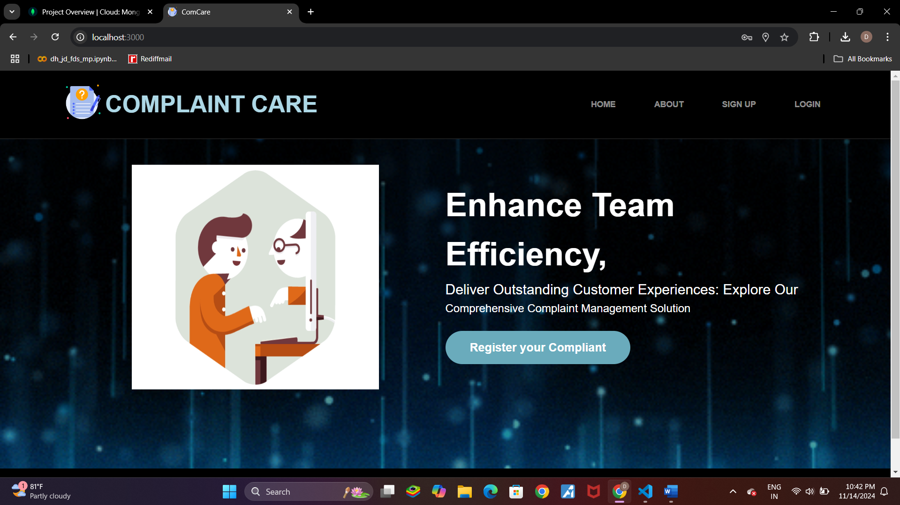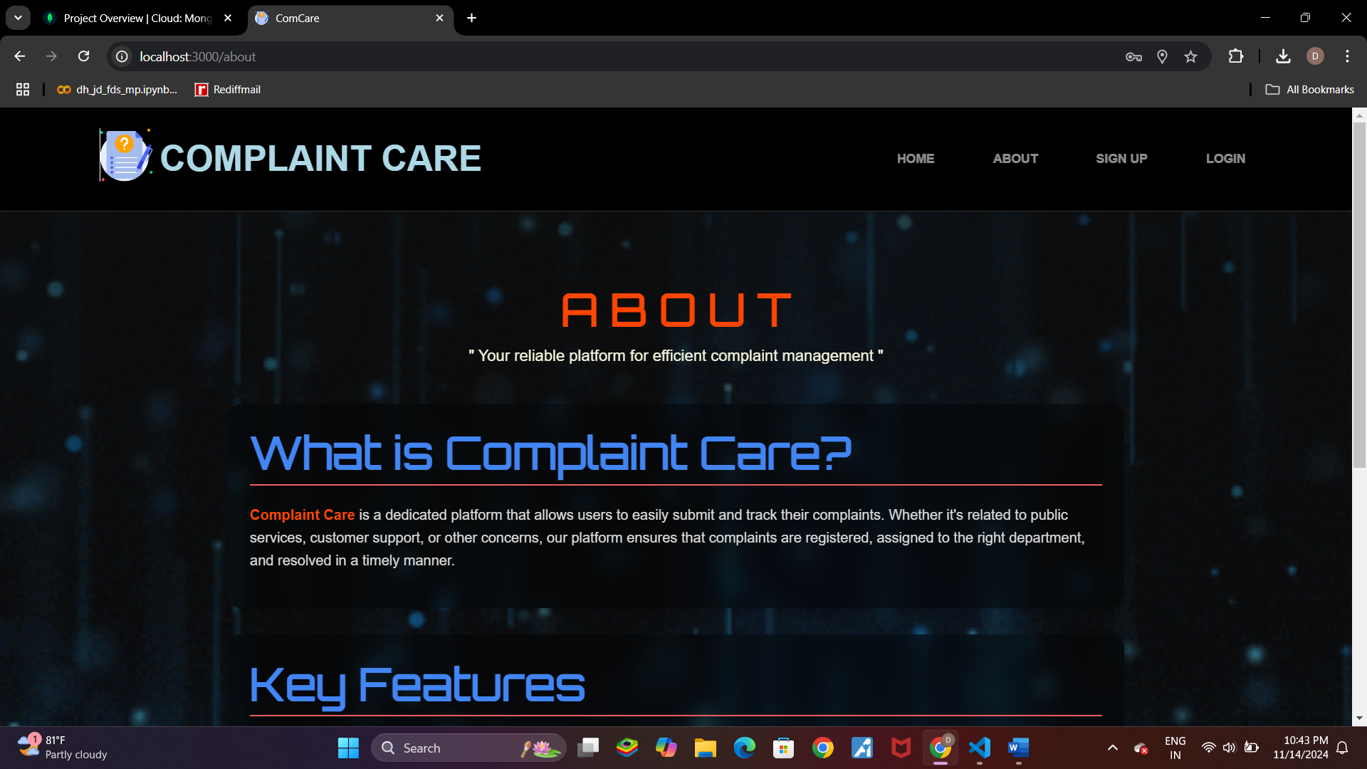

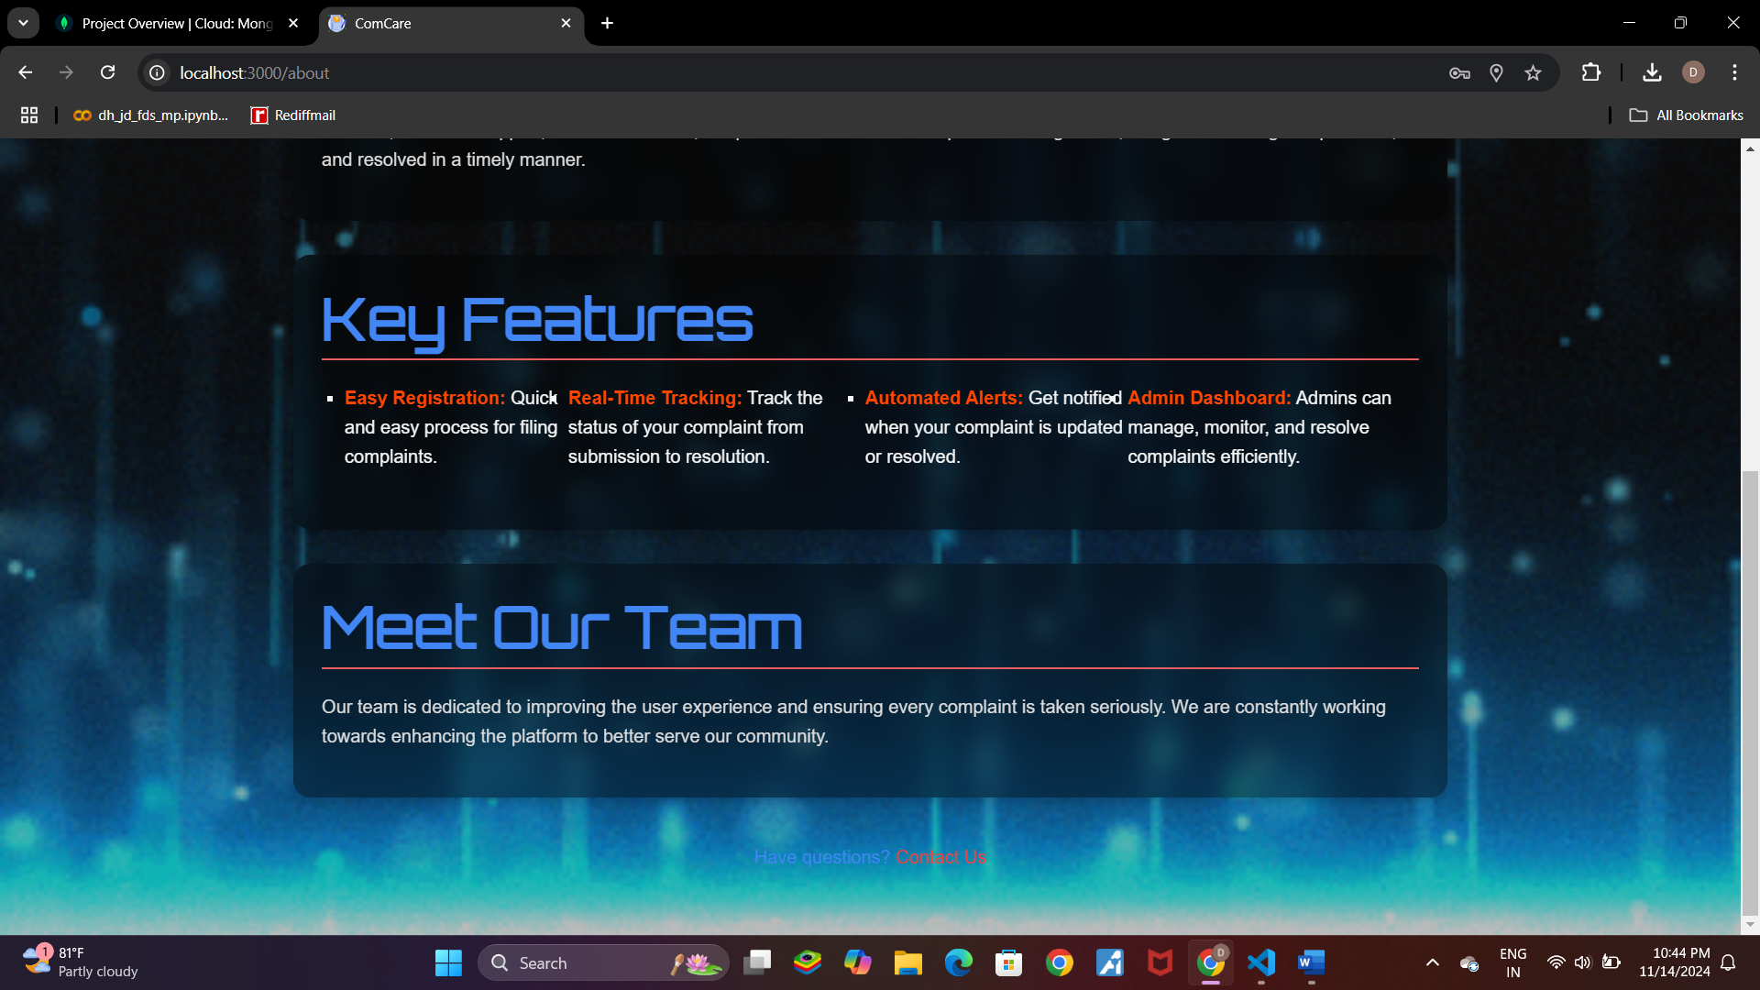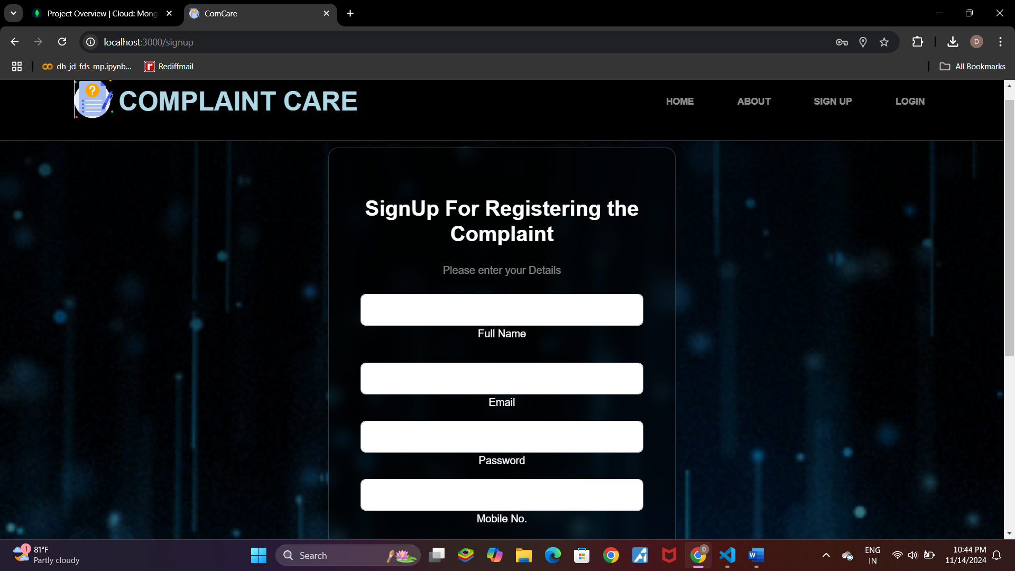

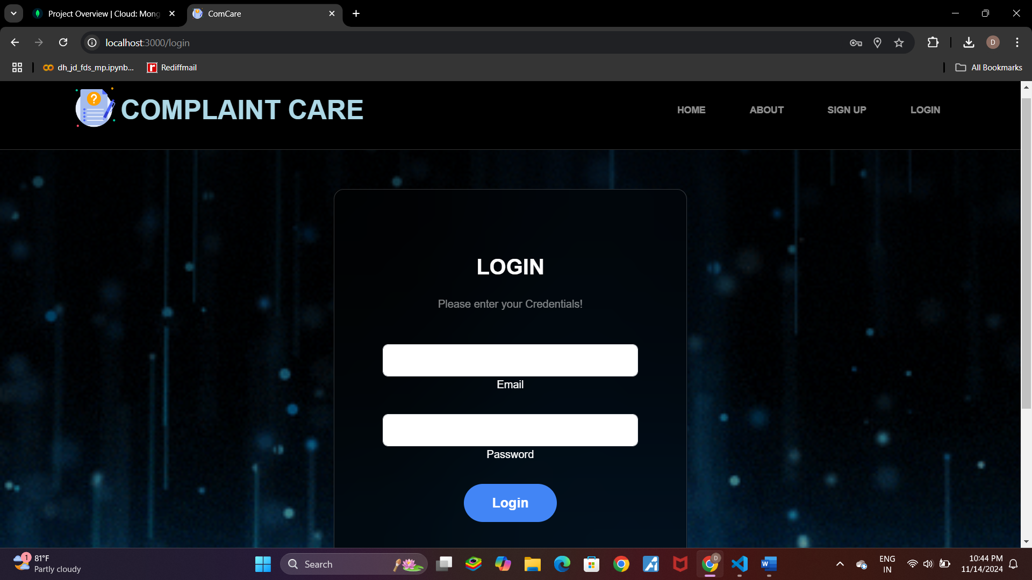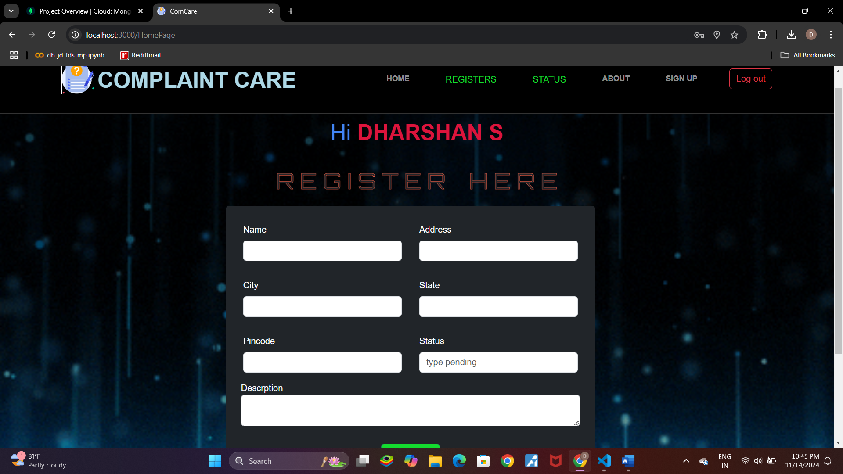

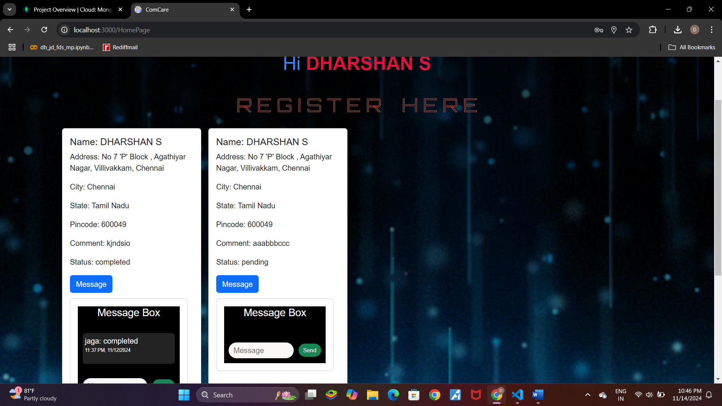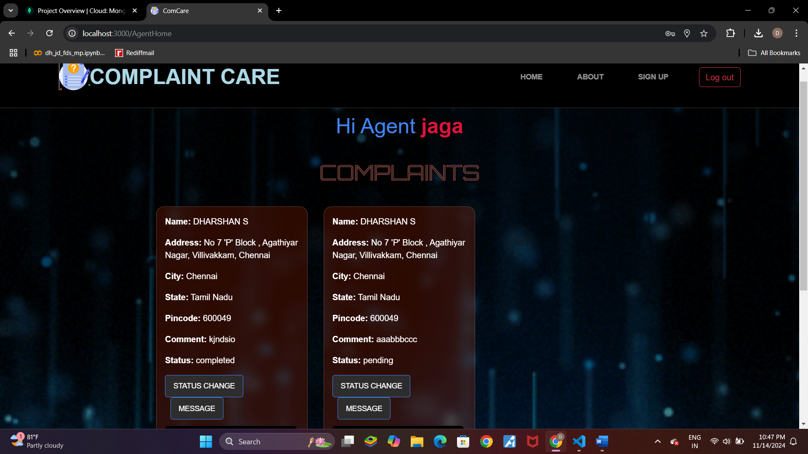

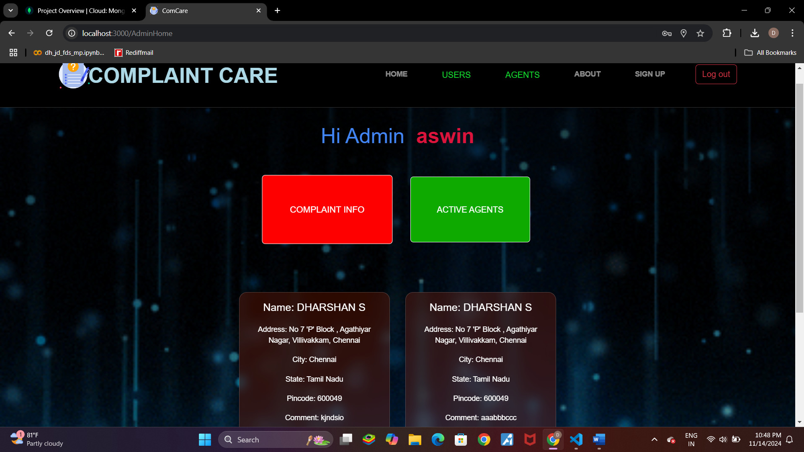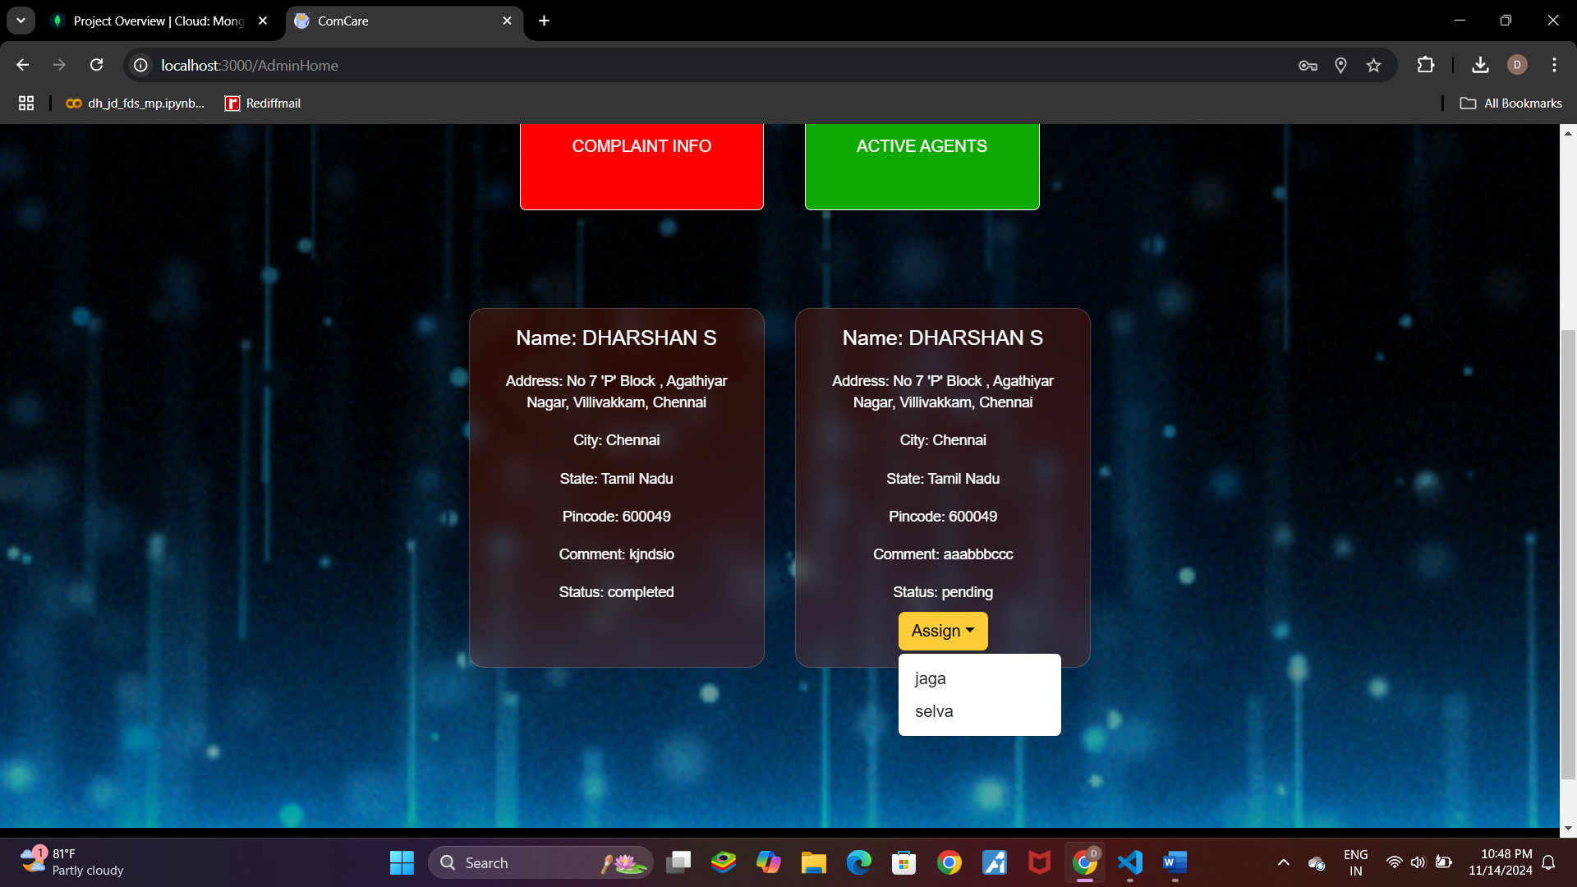

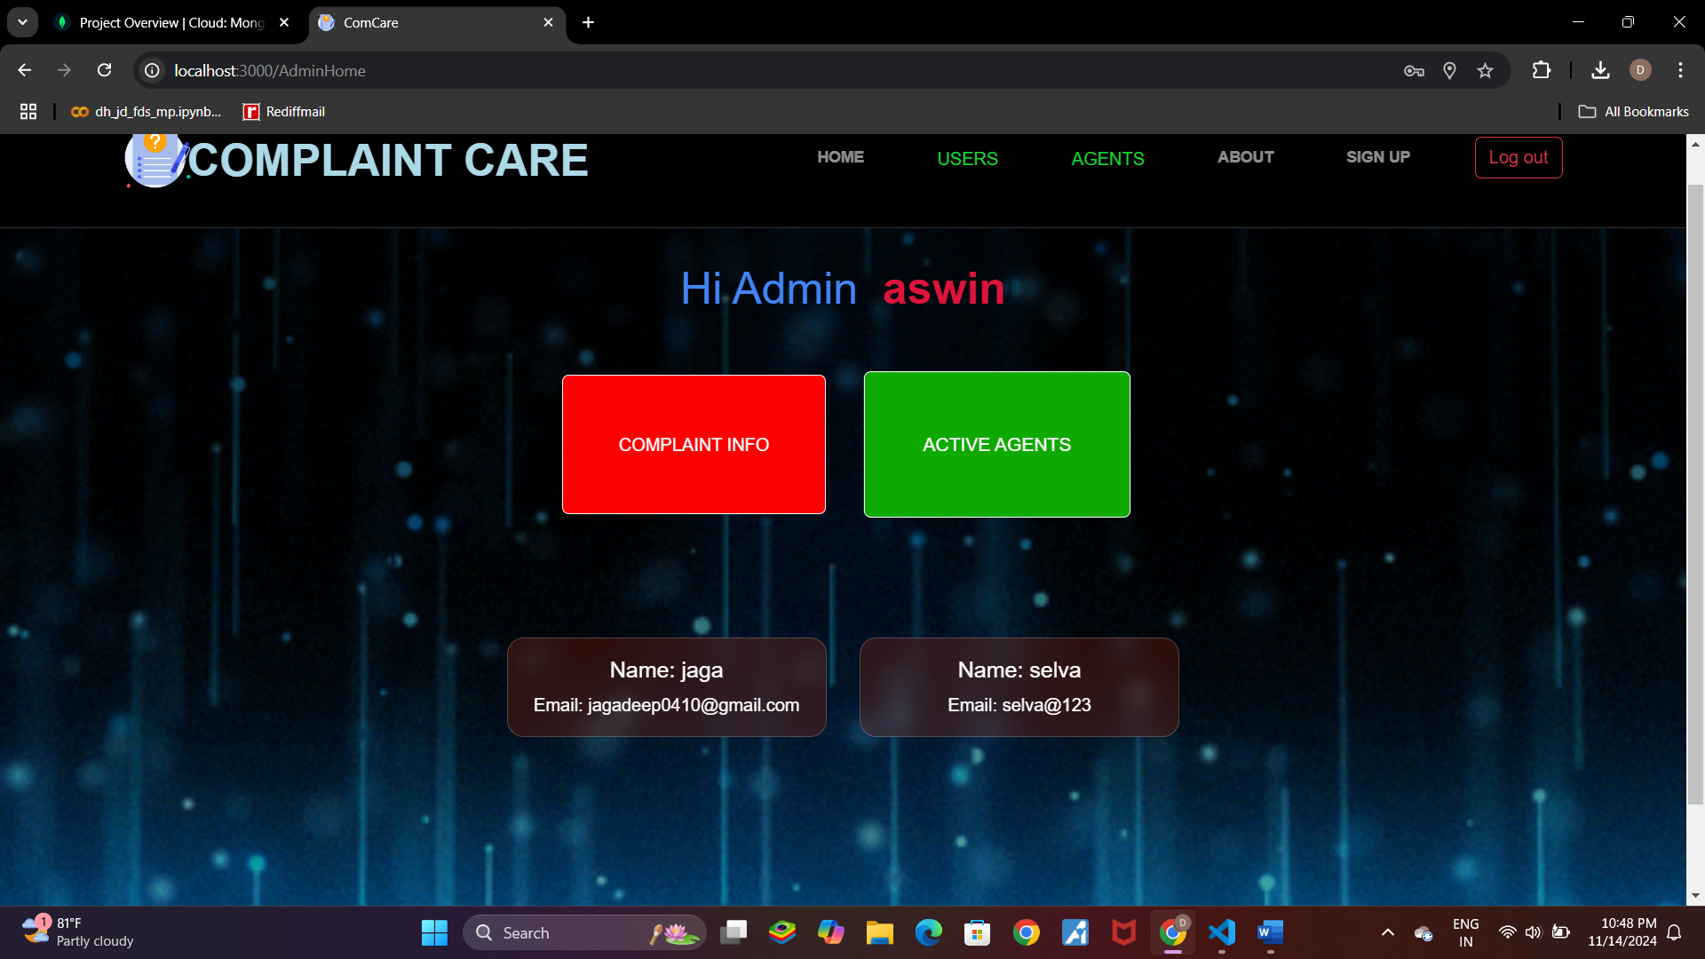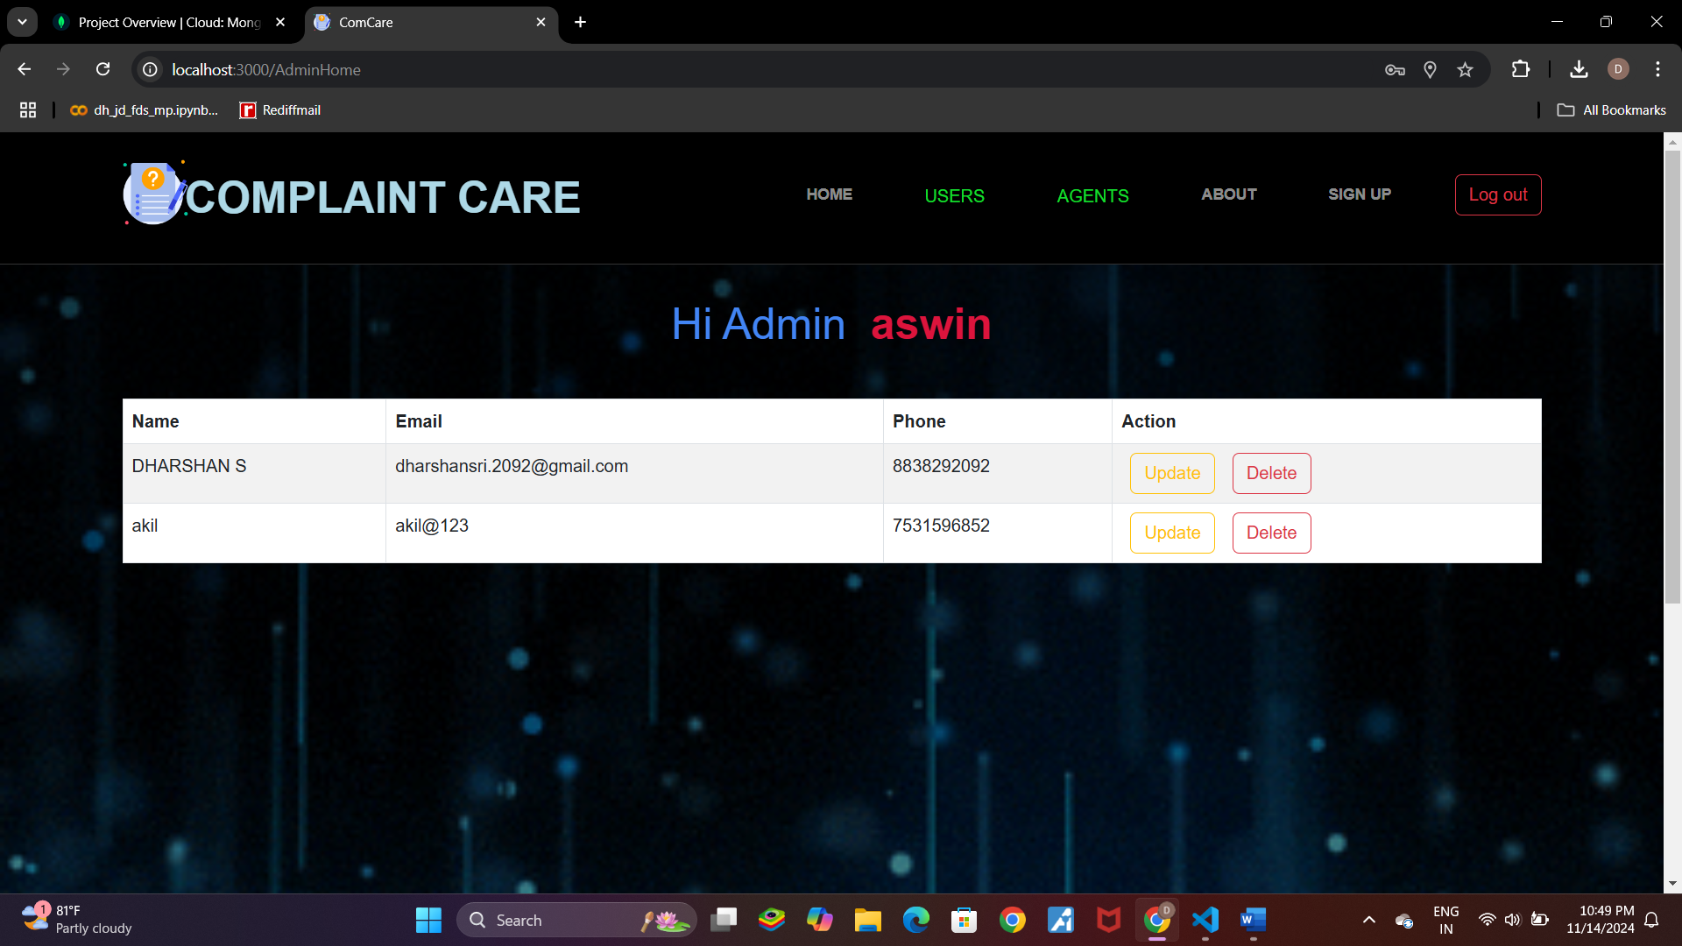

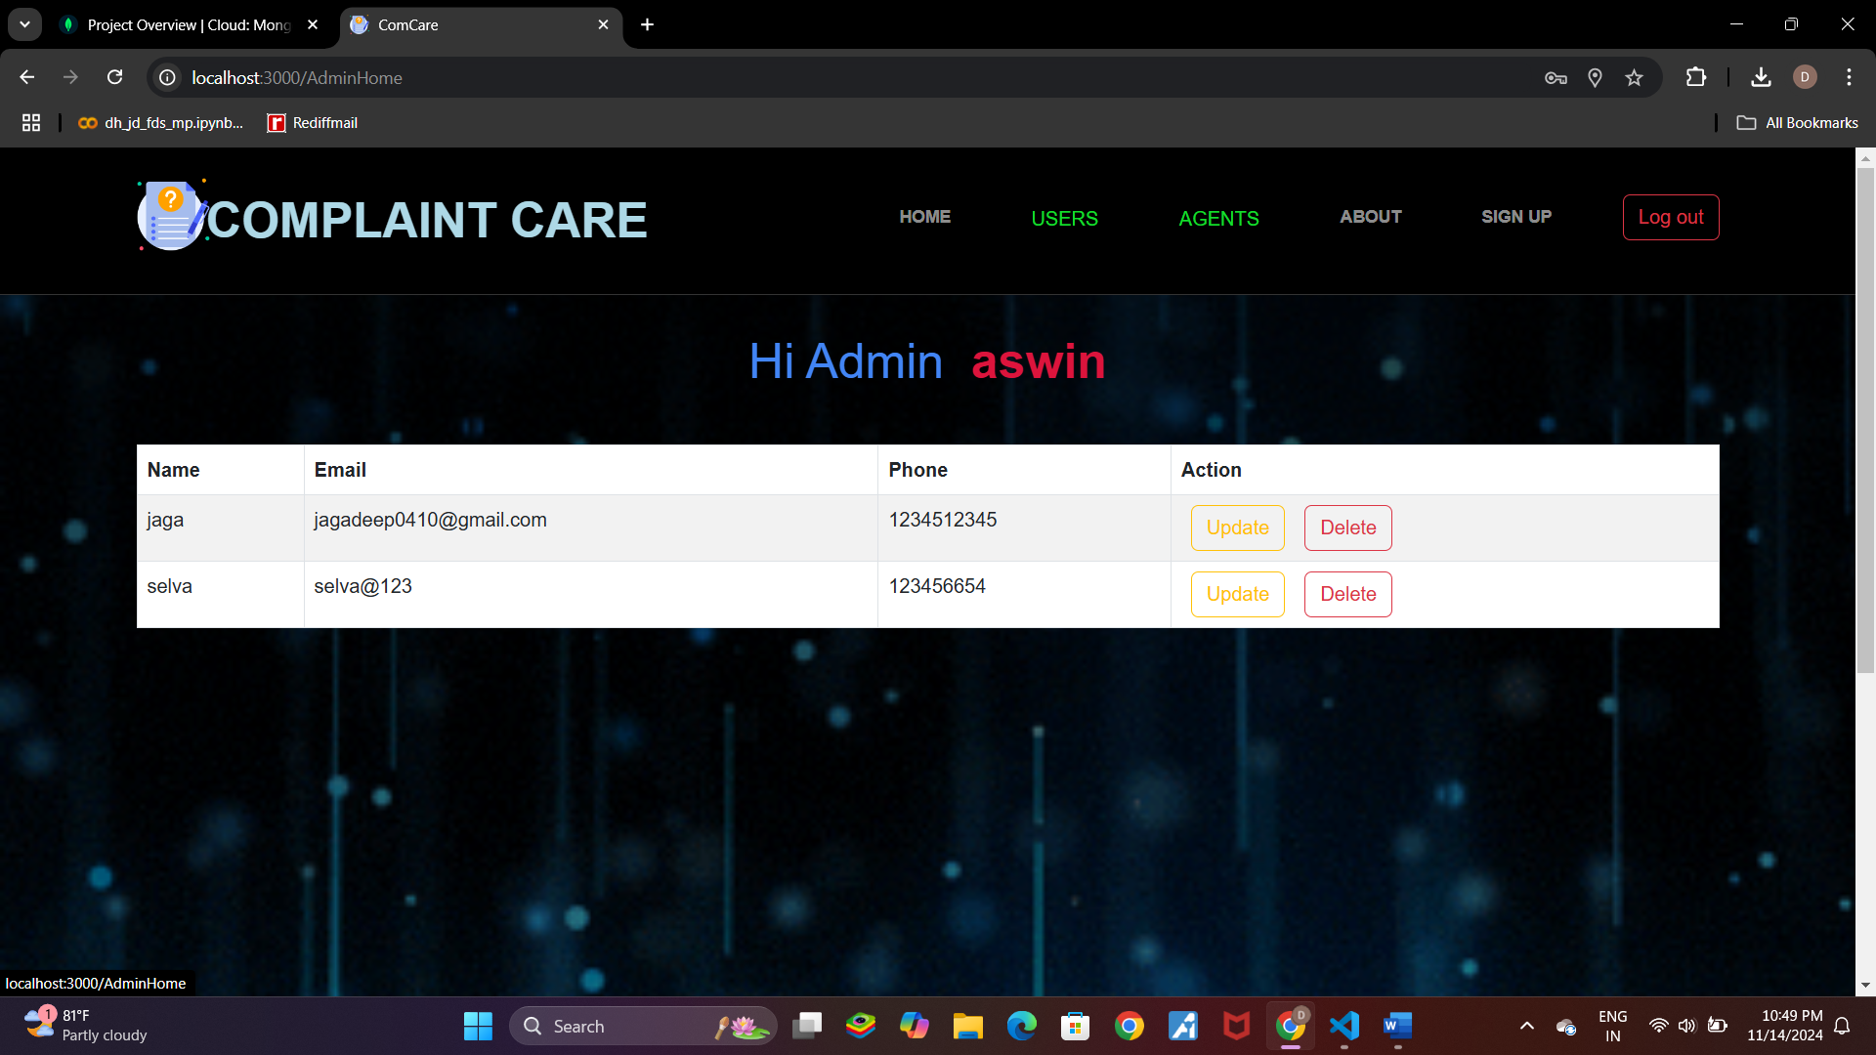

**12. Known Issues**

**Document any known bugs or limitations, such as:**

* Bug 1: Notifications not sent for some complaint updates.
* Bug 2: Complaints not being sorted by priority correctly.

**13. Future Enhancements**

Outline potential future features or improvements:

* Real-Time Chat: Allow users and agents to interact through live chat.
* Complaint Analytics: Add graphs or reports to track complaint statistics.
* Admin Dashboard Enhancements: Improve complaint categorization and filtering for admins.